

Practices for Secure Software Report

Table of Contents
Document Revision History 3
Client 3
Instructions 3
Developer 4
1. Algorithm Cipher 4
2. Certificate Generation 4
3. Deploy Cipher 4
4. Secure Communications 4
5. Secondary Testing 4
6. Functional Testing 4
7. Summary 4
8. Industry Standard Best Practices 4

Document Revision History

Version | Date | Author | Comments
1.0 | 10/19/2024 | Connor Sculthorpe

Client



Developer
Connor Sculthorpe

Algorithm Cipher

We are using the following encryption methods, varying based on the type of data:
- Over TLS, we are using TLS_AES_256_GCM_SHA384
- With the keystore, we are using ECDSA (Elliptic Curve Digital Signature Algorithm)
- For our hash function to create our checksum, we are using SHA384
- For secure logging, we are using SLF4J (Simple Logging Façade for Java) along with Logback

To be significantly less brief, let us go over each of these modules one snippet at a time.
TLS is Transport Layer Security, and this way of specifying the cipher suite is exclusive to version 1.3, the latest version, which is significantly more resistant to attackers and is recommended by industry professionals (Information Technology Laboratory, 2017). AES is short for Advanced Encryption Standard, and we are operating at a 256-bit level, where higher bit levels represent significantly more computational power to break. This is a symmetric function that uses a series of non-linear substitutions and permutations to obfuscate data in fixed blocks using a key, abusing principles of Boolean Algebra and Abstract Algebra through finite fields (Jena, 2024; Gallian, 2016, Part 4: Fields). GCM, or Galois Counter Mode, is similarly clever in its use of Galois Fields (known simply as fields) to create certificates, as finite fields exist as vector spaces and thus solving them requires solving a complex discrete logarithm problem that, from experience, takes a significant amount of time. In TLS 1.3, ECDHE or Elliptic Curve Diffie-Hellman Ephemeral is another trick of Abstract Algebra where we use a group of integers closed under modular arithmetic to provide ourselves forward secrecy in a key exchange, where a breach to one key does not unlock all past locks (Sullivan, 2024). Finally, the last part of this suite is SHA, Secure Hashing Algorithm at bit level 384, a highly secure method which generates a cryptographic hash that is one-to-one but not unto. This means that there is some $b$ where the text we are hashing $a$ through a mapping function $ϕ\left(a\right)= ϕ(b)$ in a non-symmetric (destructive) manner (Gallian, 2016, ch. 2 Groups as cited in Sculthorpe, 2024). This is desirable, as it means you cannot reverse-engineer the message from the checksum.
Next, we have our keystore using Elliptic Curve Digital Signature Algorithm. This is actually quite similar to ECDHE in mathematical terms, but it serves a very different purpose. Here, we are using it to sign a message for authenticity. As long as you have the public key, you can verify this signature. I chose this over RSA encryption, as RSA operates as a ring rather than a field and thus some of its mathematical properties slow it down and bloat its size for the same bit level.
As previously explained, SHA-384 is great for creating checksums, and hashing algorithms are blisteringly quick, rarely hitting their $O(n)$ and are more easily understood by their $θ(1)$ complexity.
Finally, SLF4J and Logback are a complimentary pair of logging libraries for Java that allow us to securely generate log events with relevant information (Manico et al., 2014, pp. 222-230). Although not fully expanded on here due to it being out of project scope, secure log events prevent the leakage of stack trace, session ID’s, and more. The importance of this cannot be understated, as even the IEEE fell prey to this failure and over one hundred thousand passwords of high-profile individuals were breached (Dragusin, 2012 as cited in (Manico et al., 2014).

Certificate Generation
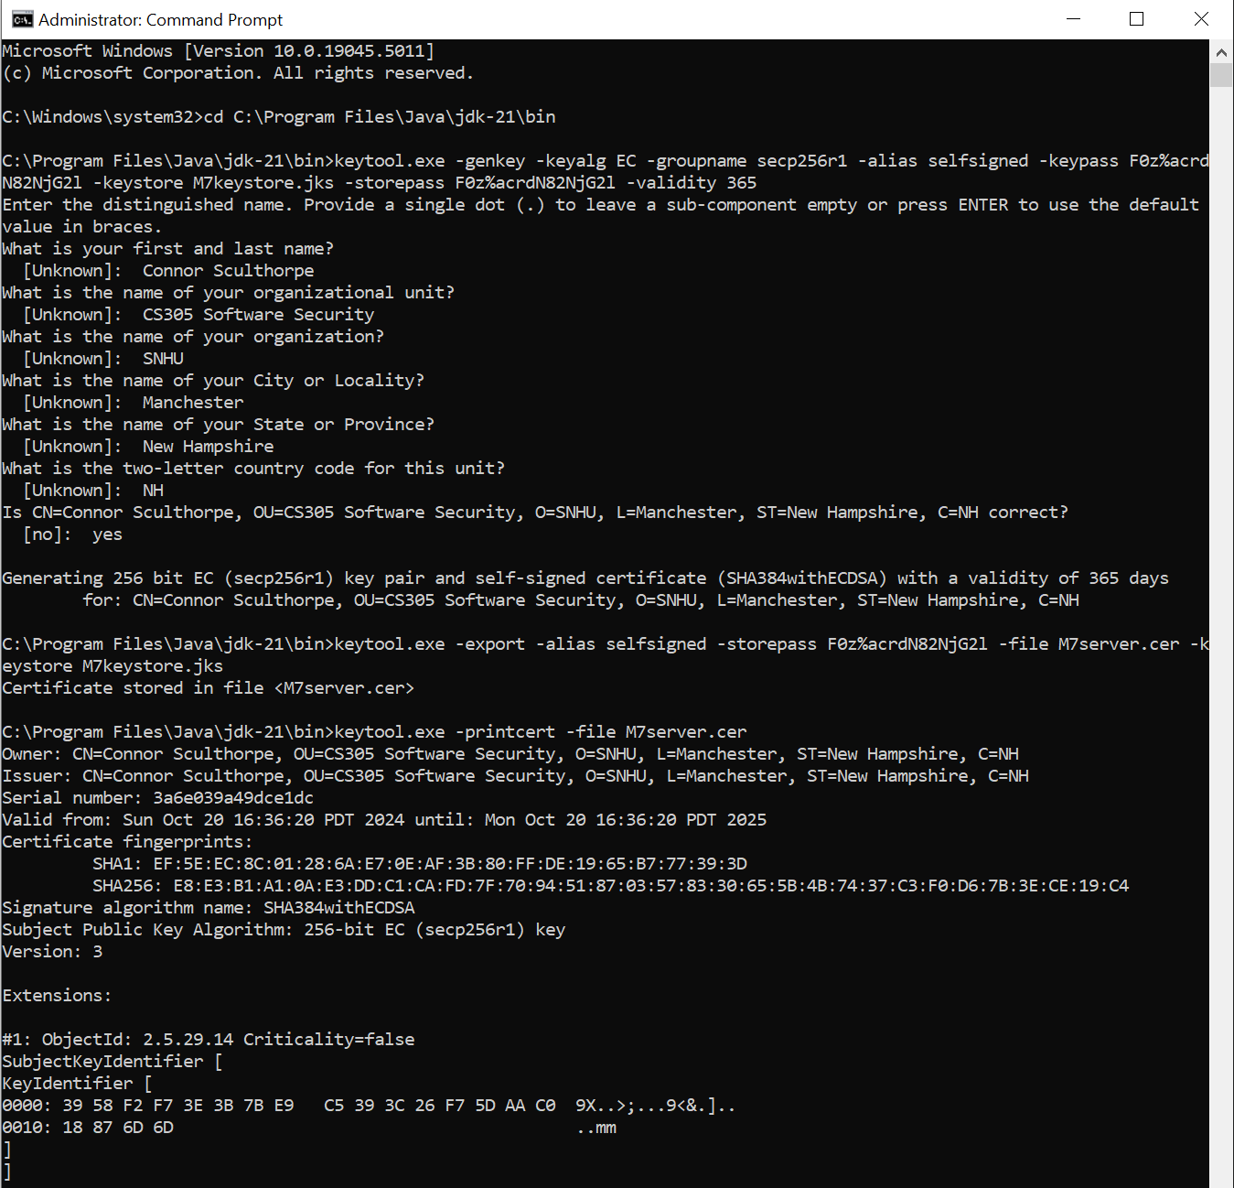

Deploy Cipher
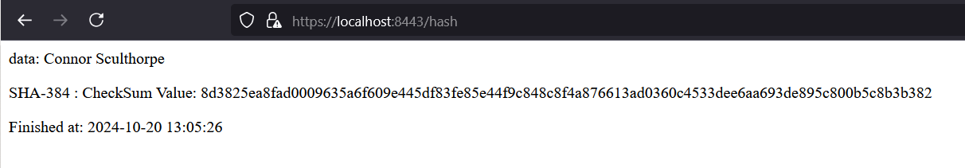

Secure Communications
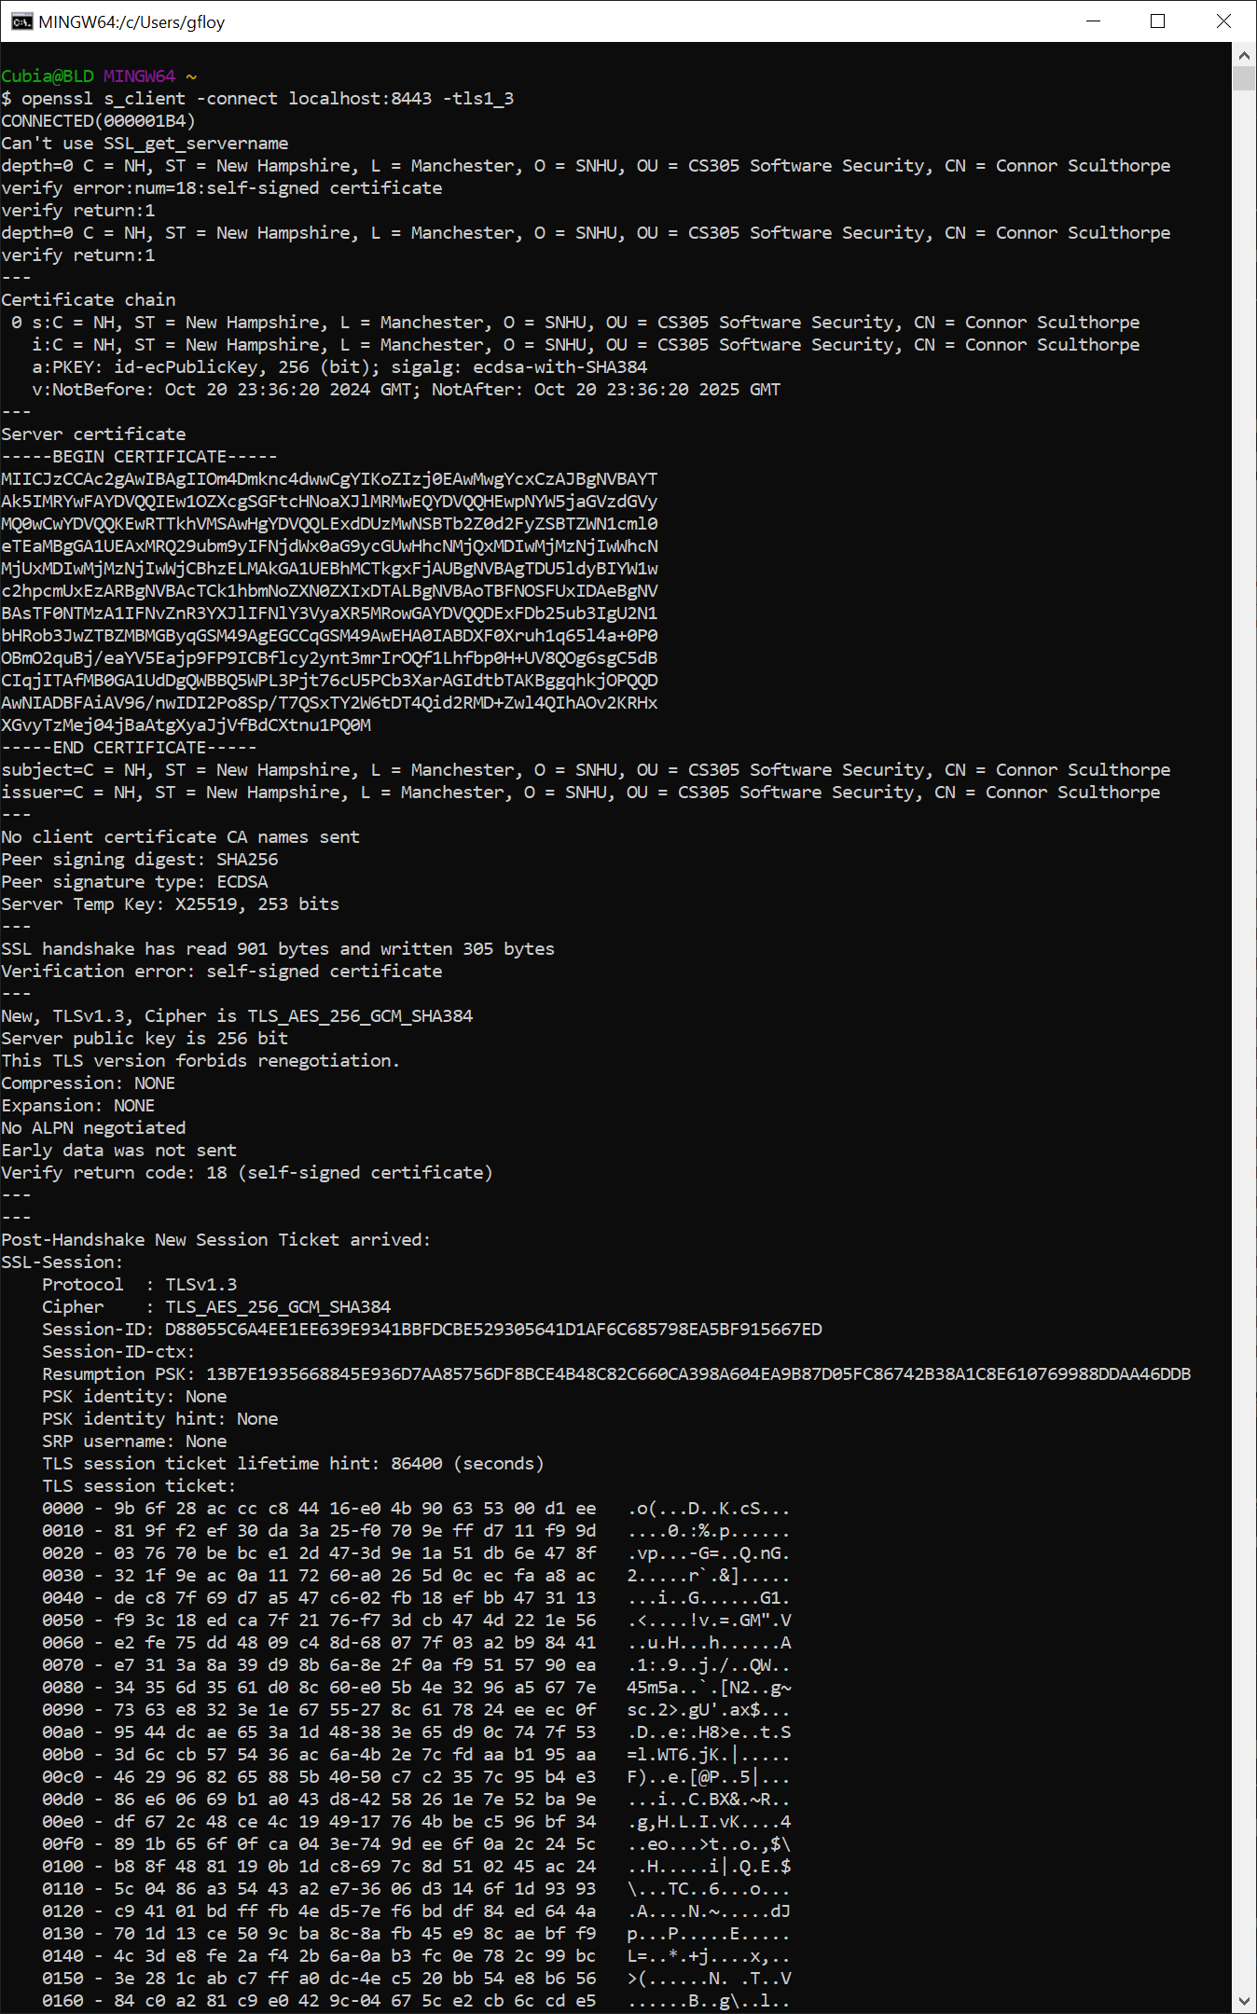

Secondary Testing

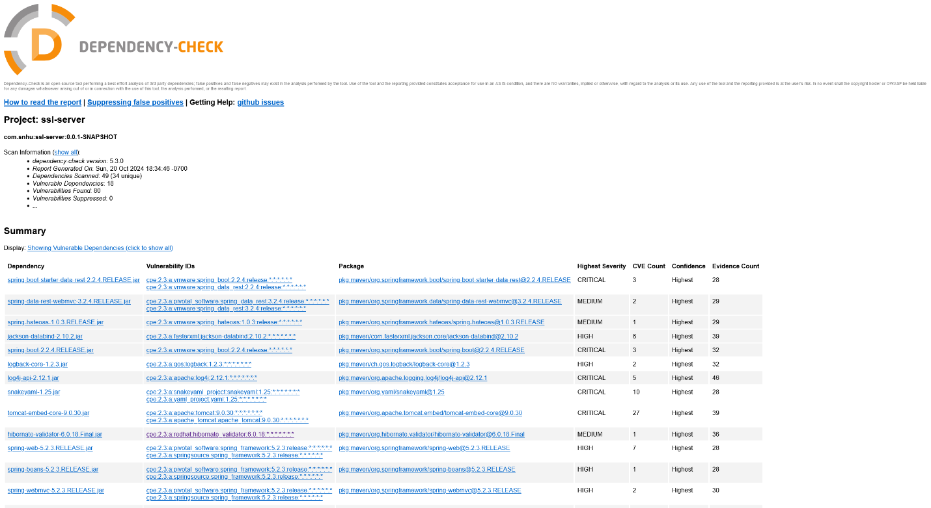
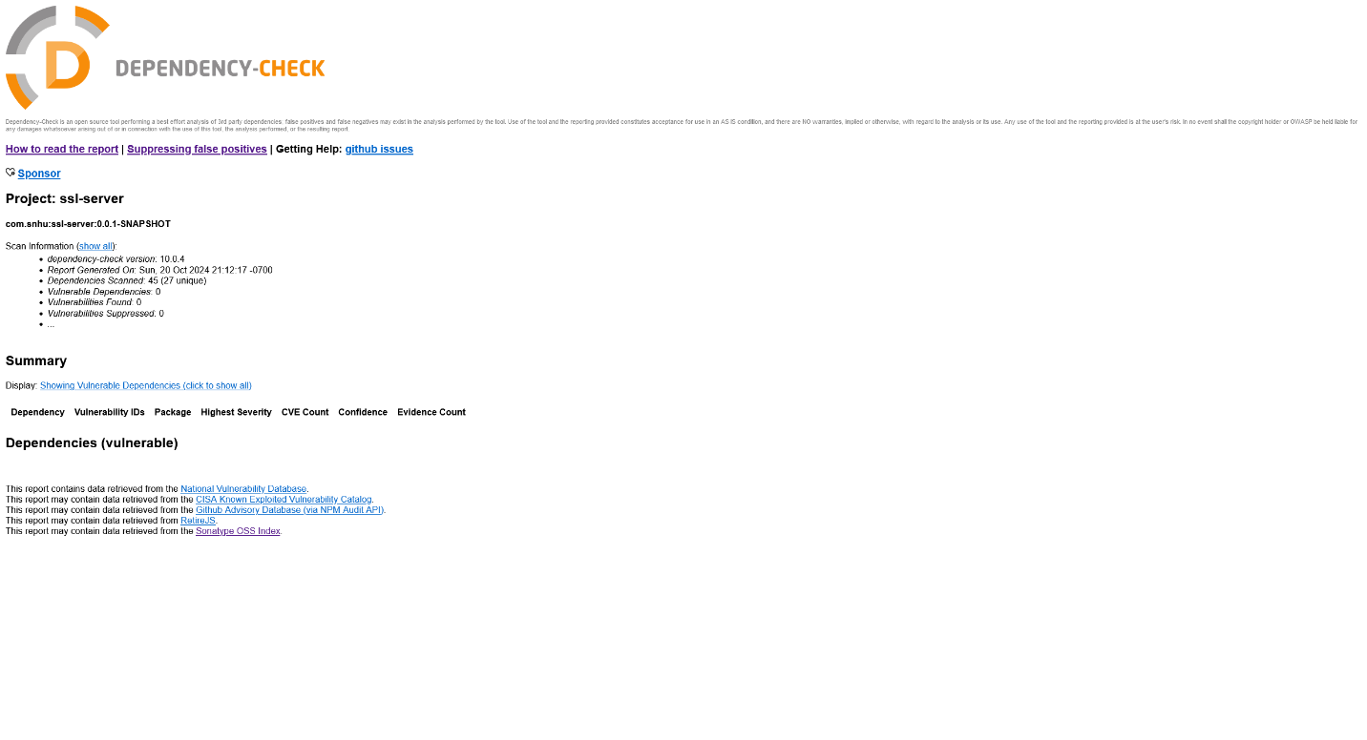

Application.properties

### Copied from wk6 project, looks to protect against file download size attacks?
## MULTIPART (MultipartProperties)
# Enable multipart uploads
spring.servlet.multipart.enabled=true
# Threshold after which files are written to disk.
spring.servlet.multipart.file-size-threshold=2KB
# Max file size.
spring.servlet.multipart.max-file-size=200MB
# Max Request Size
spring.servlet.multipart.max-request-size=215MB

server.ssl.enabled=true
server.port=8443

# TLS Configuration
server.ssl.key-alias=selfsigned
server.ssl.key-store-password=F0z%acrdN82NjG2l
server.ssl.key-store=C:/Program Files/Java/jdk-21/bin/M7keystore.jks
server.ssl.key-store-type=JKS
server.ssl.key-password=F0z%acrdN82NjG2l

# Force the use of TLS 1.3
server.ssl.enabled-protocols=TLSv1.3

# Set our cipher suite, forcing only this connection type
server.ssl.ciphers=TLS_AES_256_GCM_SHA384

SslServerApplication.java
package com.snhu.sslserver;

import java.io.UnsupportedEncodingException;
import java.security.MessageDigest;
import java.security.NoSuchAlgorithmException;
import java.time.LocalDateTime; // Date() is deprecated
import java.time.format.DateTimeFormatter; // We need to format our localdate

import org.springframework.boot.SpringApplication;
import org.springframework.boot.autoconfigure.SpringBootApplication;
import org.springframework.http.HttpStatus;
import org.springframework.http.ResponseEntity;
import org.springframework.web.bind.annotation.RequestMapping;
import org.springframework.web.bind.annotation.RestController;

import org.slf4j.Logger;
import org.slf4j.LoggerFactory;

@SpringBootApplication
public class SslServerApplication {

public static void main(String[] args) {
SpringApplication.run(SslServerApplication.class, args);
}

}

//FIXME: Add route to enable check sum return of static data example: String data = "Hello World Check Sum!";

@RestController
class ServerController{

private static final Logger logger = LoggerFactory.getLogger(ServerController.class); // Spin up slf4j logger

@RequestMapping("/hash")
public ResponseEntity<String> myHash(){
final String data = "Connor Sculthorpe"; // My name to hash
String dataHash = null;
LocalDateTime now = LocalDateTime.now();
DateTimeFormatter formatter = DateTimeFormatter.ofPattern("yyyy-MM-dd HH:mm:ss");

if (data == null) { // Blacklist
logger.error("Data to hash is null");
now = LocalDateTime.now();
return ResponseEntity.status(HttpStatus.BAD_REQUEST) // https://spring.io/guides/tutorials/rest
.body("<p>Error 400: Data to hash cannot be null</p>" +
"<p>Occurred at: "+ now.format(formatter) + "</p>");
}

try {
dataHash = generateHash(data); // call our hashing function
} catch (NoSuchAlgorithmException | UnsupportedEncodingException e) {
logger.error("Something went wrong with calling the hash function", e); // Log the error if one is thrown
now = LocalDateTime.now(); // Get our time and date for printing
ResponseEntity.status(HttpStatus.INTERNAL_SERVER_ERROR)
.body("<p>Error 500: Error occurred while calling the hash function</p>" +
"<p>Occurred at: "+ now.format(formatter) + "</p>"); // Tell the user what has gone wrong generally and when
}
// Our hash should be:
// 8d3825ea8fad0009635a6f609e445df83fe85e44f9c848c8f4a876613ad0360c4533dee6aa693de895c800b5c8b3b382
// Thanks to: https://emn178.github.io/online-tools/sha384.html
now = LocalDateTime.now();
return ResponseEntity.status(HttpStatus.OK)
.body("<p>data: " + data + "</p><p>SHA-384 : CheckSum Value: " + dataHash + "</p>" +
"<p>Finished at: " + now.format(formatter) + "</p>");
}

/**
* Generates a SHA-384 hash from an input string.
*
* Time: O(n), θ(1), Ω(1)
* Space: O(n+k)
* @param String data
* @return String dataHashed
* @throws NoSuchAlgorithmException, UnsupportedEncodingException
* References: https://stackoverflow.com/questions/5531455/how-to-hash-some-string-with-sha-256-in-java
*/
private String generateHash(String data) throws NoSuchAlgorithmException, UnsupportedEncodingException {
final MessageDigest md = MessageDigest.getInstance("SHA-384"); // Create message digest obj
final byte[] digest = md.digest(data.getBytes("UTF-8")); // Compute the message digest (byte array)
StringBuilder hexString = new StringBuilder(); // Buffer to move our data into, use StringBuffer for thread safety if needed
for (int i = 0; i < digest.length; i++) {
final String hex = Integer.toHexString(0xff & digest[i]);
if (hex.length() == 1) {
hexString.append('0'); // Leading zeroes
}
hexString.append(hex);
}
return hexString.toString();
}
}

pom.xml
<?xml version="1.0" encoding="UTF-8"?>
<project xmlns="http://maven.apache.org/POM/4.0.0" xmlns:xsi="http://www.w3.org/2001/XMLSchema-instance"
xsi:schemaLocation="http://maven.apache.org/POM/4.0.0 https://maven.apache.org/xsd/maven-4.0.0.xsd">
<modelVersion>4.0.0</modelVersion>
<parent>
<groupId>org.springframework.boot</groupId>
<artifactId>spring-boot-starter-parent</artifactId>
<version>3.3.4</version>
<relativePath/> <!-- lookup parent from repository -->
</parent>
<groupId>com.snhu</groupId>
<artifactId>ssl-server</artifactId>
<version>0.0.1-SNAPSHOT</version>
<name>ssl-server</name>
<description>ssl-server skeleton for CS-305</description>

<properties>
<java.version>21</java.version>
</properties>

<dependencies>
<dependency>
<groupId>org.springframework.boot</groupId>
<artifactId>spring-boot-starter-data-rest</artifactId>
</dependency>

<dependency>
<groupId>org.springframework.boot</groupId>
<artifactId>spring-boot-starter-web</artifactId>
</dependency>

<dependency>
<groupId>org.springframework.boot</groupId>
<artifactId>spring-boot-starter-test</artifactId>
<scope>test</scope>
<exclusions>
<exclusion>
<groupId>org.junit.vintage</groupId>
<artifactId>junit-vintage-engine</artifactId>
</exclusion>
</exclusions>
</dependency>

<!-- https://mvnrepository.com/artifact/com.fasterxml.jackson.core/jackson-databind -->
<dependency>
<groupId>com.fasterxml.jackson.core</groupId>
<artifactId>jackson-databind</artifactId>

</dependency>

<dependency>
<groupId>com.jayway.jsonpath</groupId>
<artifactId>json-path</artifactId>
</dependency>

<dependency>
<groupId>org.yaml</groupId>
<artifactId>snakeyaml</artifactId>

</dependency>

<!-- https://mvnrepository.com/artifact/org.springframework/spring-core -->
<dependency>
<groupId>org.springframework</groupId>
<artifactId>spring-core</artifactId>

</dependency>

<!-- https://mvnrepository.com/artifact/org.springframework/spring-web -->
<dependency>
<groupId>org.springframework</groupId>
<artifactId>spring-web</artifactId>

</dependency>

<!-- https://mvnrepository.com/artifact/ch.qos.logback/logback-classic -->
<dependency>
<groupId>ch.qos.logback</groupId>
<artifactId>logback-classic</artifactId>

<scope>test</scope>
</dependency>

<dependency>
<groupId>org.springframework</groupId>
<artifactId>spring-webmvc</artifactId>
<version>6.1.14</version>
</dependency>

<!-- https://mvnrepository.com/artifact/commons-io/commons-io -->
<dependency>
<groupId>commons-io</groupId>
<artifactId>commons-io</artifactId>
<version>2.17.0</version>
</dependency>

<dependency>
<groupId>org.slf4j</groupId>
<artifactId>slf4j-api</artifactId>
</dependency>

</dependencies>

<build>
<plugins>
<plugin>
<groupId>org.springframework.boot</groupId>
<artifactId>spring-boot-maven-plugin</artifactId>
</plugin>
<plugin>
<groupId>org.owasp</groupId>
<artifactId>dependency-check-maven</artifactId>
<version>10.0.4</version>
<configuration>
<suppressionFiles>
<suppressionFile>suppression.xml</suppressionFile>
</suppressionFiles>
</configuration>
<executions>
<execution>
<goals>
<goal>check</goal>
</goals>
</execution>
</executions>
</plugin>
</plugins>
</build>

</project>

Functional Testing
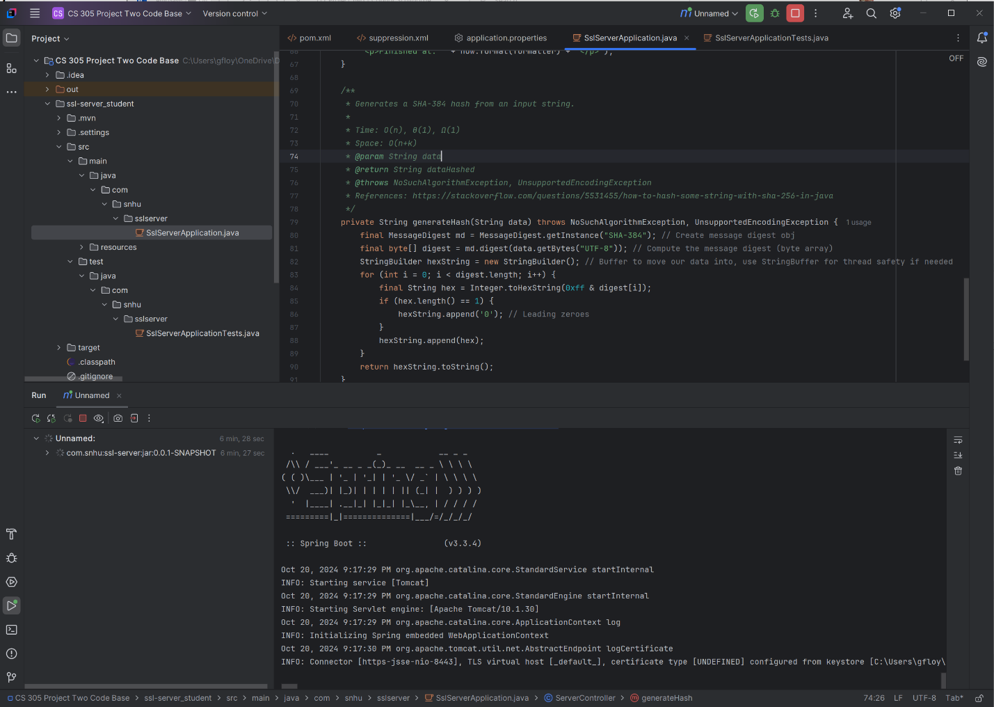
I have a strong preference for Intellij after I was able to diagnose and resolve bugs far quicker with it than with Eclipse. It also makes far more sense to my brain to order Maven to operate as “-X spring-boot:run” than it is to entirely skip Maven and launch as an application as Eclipse likes to default to. It also looks cleaner to me, which is nice. Perhaps I have spent too much time in Visual Studio with my C++ projects. I made sure to include the raw code with its formatting above, although you may have to enable editing to expand or collapse their headings to display them.

Summary
A large number of vulnerabilities were identified and addressed with this refactoring. I walked through the conceptual map of the intended program, reflecting on if each module was secure. Our server was connecting over HTTP, rather than its secure cousin HTTPS as it now does. Furthermore, the keys were being stored with RSA Encryption, a slower and less effective method of protecting keys, which I rectified. When I then started working on the code itself, I made sure to generate an initial report with OWASP Dependency Checker on its initial version, as well as another after updating it to version 10.0.4 to obtain more recent assessments of vulnerabilities. I iterated module by module, increasing the version of the Spring Framework to 3.3.4, its most recent version. This alone solved nearly every CVE listing. Updating Spring-WebMVC was blocked by lacking a higher version of Commons-io, so I rectified both issues and brought them up to date. I also made sure to move to a higher version of Java, that way future support for modules would be much more painless. At this point, the static analysis showed that none of the modules had any known vulnerabilities. Finally, I imported my code from week 5 with some updates, generating a hash of my name and producing a time stamp to prove when the function was last run while still programming the functions defensively, making sure to leave room for future expansion on the code base.

Industry Standard Best Practices

I believe security is best understood in layers. No one single layer will stop an attacker, but with all layers, nearly every attacker will be thwarted. With this in mind, I started from the heart of the program and moved outward, adding on more layers of security along the way. By choosing a highly secure password for the keytool and picking an algorithm that is more secure and operates more quickly, I bolstered the core of the program by protecting its keys more carefully. After all, according to Manico et al. (2014) “…cryptography turns the problem of protecting a lot of information – your data – into the problem of protecting a little information: the keys”.
Next, I turned to the Vulnerability Assessment Process Flow diagram provided for this class by SNHU. Moving through each tile, we are not handling input, but we are worried about our API’s, but thankfully they have been selected for us, so we only need to follow their protocols for secure interactions. For cryptography, this was the main function of the program, so it was a major focus and the only reason I did not reach for SHA-512 was for its slight increase in time and space complexity over SHA-384 where both of them have bit levels that are absurdly difficult for current and near-future computers. Code error was also a major focus of mine, as exceptions are easy to forget, but failing safely and sending any failure to a log means that we can have some peace of mind with what our code will do when the unexpected happens. Code quality is also always a major focus of mine, as I made sure to use positive patterns and detailed code comments throughout my work, including asymptotic analysis of algorithms that I placed in the code. Finally, our server file follows the object-oriented principle of encapsulation by default in this assignment, as we are only handling three functions, main, the top-level function to display the /hash page and call the hash function, and the hash function itself. Finally, I set up a certificate pinning scaffold for us to begin to create, as its creation was out of the scope of this project, but having the scaffold on hand will encourage developers to finish the module and grant an extra layer of security.
All these added layers of security give us a robust defense against intrusion. Artemis Financial is trusting us to produce high-quality protection to ensure that their fiduciary duty will not be violated and thus shield them from legal trouble with their customers and the federal government (Legal Information Institute, 2022), and it is my opinion that we have delivered on this desire. By also making sure to create code that is easily expanded upon, we turn over the opportunity for Artemis Financial to work in an Agile fashion with us in the future, rather than how we have delivered this product in a Waterfall method. Continuous Integration and Continuous Deployment are a cornerstone of operations, and as developers who are mindful of security and use simple operations tools like GitHub, Maven, and OWASP we prepare our developer side of the equation for our operations and security teams. We are therefore attempting to embody the intention of DevSecOps, keeping each of these parts of a company unsiloed allows for the continued success of the deployed software, and of every party involved (Jeganathan, 2019). By embracing this change early, we allow not just our organization to succeed, but we also deliver significantly higher quality products to our customers, in this case, Artemis Financial.

References
Gallian, J. A. (2016). Contemporary Abstract Algebra (9th ed.). Cengage Learning.
Information Technology Laboratory (2017, January 04). Hash Functions. U.S. Department of Commerce, National Institute of Standards and Technology. https://csrc.nist.gov/projects/hash-functions
Jeganathan, S. (2019). DevSecOps: A Systemic Approach for Secure Software Development. Information Systems Security Association, 17(11).
Jena, B. K. (2024, July 16). AES encryption: Secure Data with Advanced Encryption Standard. Simplilearn.com. https://www.simplilearn.com/tutorials/cryptography-tutorial/aes-encryption
Legal Information Institute. (2022, December). Fiduciary duty. https://www.law.cornell.edu/wex/fiduciary_duty
Manico, J., Detlefsen, A., & Kenan, K. (2014). Iron-Clad Java: Building Secure Web Applications (M. Smith, Ed.). McGraw-Hill Education.
Sculthorpe, C. (2024). 5-1 Checksum Verification - Connor Sculthorpe.
Seetharaman, J. (2019). DevSecOps: A Systemic Approach for Secure Software Development. ISSA Journal
Sullivan, N. (2024, October 9). A (relatively easy to understand) primer on elliptic curve cryptography. Cloudflare. https://blog.cloudflare.com/a-relatively-easy-to-understand-primer-on-elliptic-curve-cryptography/

